May 2026 Regular Meeting Call Of The Williamsburg-James City County Republican Committee

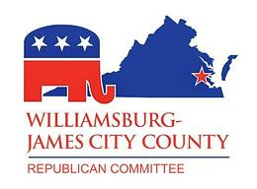

6:30 P.M. May 27th 2026 At The Colonial Heritage Club House
6500 Arthur Hills Drive, Williamsburg, VA 23188

Directions In Link Below

https://maps.app.goo.gl/oBF8FdJJ2q3BE1bHA

Agenda

6:30 Meeting begins
- Prayer and Pledge of Allegiance
- Roll call of Members
- New Business
- Vote in New Members
- Vote on Audit Committee
- Discussion & Vote for new Vice Chair of Membership and Secretary
- Discussion & Vote on the Budget- Neal Burton
- Discussion & Vote on allocation for new web site Curtis Rempel & Len Cheney
- Precinct Recap from April 21st- Curtis Rempel
- Discussion & vote on allocation for Get Out the Vote campaign and PAB sign up- Steve Mains
- Recap of the Just Right Party and Future Events- Debra Price
- Recap of the Referendum Defeat- Chris Woodfin
- Good of the Order (3 minutes per speaker)
- Chairman Time- Vincent Passero
- Adjourn



WJCCRC | P.O. Box 2104 | Williamsburg, VA 23187 US

Unsubscribe | Update Profile | Constant Contact Data Notice



