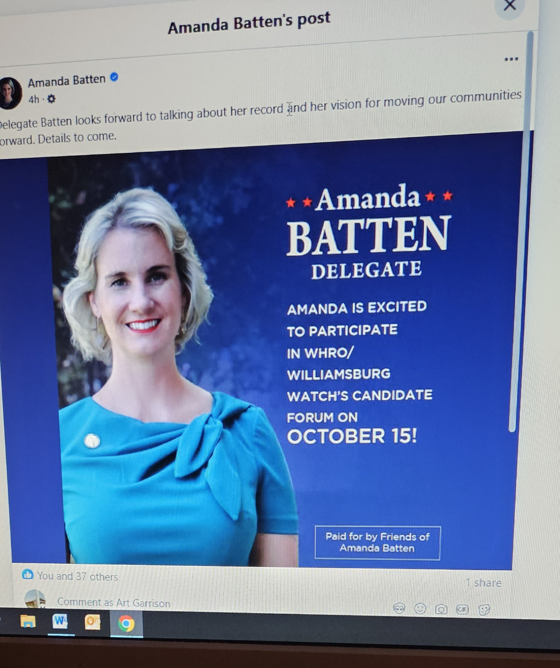

Please start sharing this!  
  
*I hope this is open to the public. We need to flood the room! Plenty of time to prepare and hopefully get some bodies to support her. We don't want or need to, Anderson* ***not*** *representing us in Richmond as she is a very liberal thinking, and extreme far left candidate without any political experience who will just vote the left’s way on everything.*